Ecclesia Church of God in Christ
533 Sharpe Road * Columbia, South Carolina *786-9597* ecclesia1.org
Sunday, August 11 2019

Pastor: Elder Luther Holmes, Jr.
Women’s Department President: Mother Sallie M. Zeigler

“Women’s Day”

Praise and Worship Praise Team

*Call to Worship

*Invocation Evangelist Ella King

*Old Testament Asp. Miss’y Tonia James

*New Testament Sister Yanique Salmon

Welcome The MC

Ask the Visitors to stand and introduce themselves. Please tell them that they will receive a Visitors Packet from the Ushers. After they fill out the Visitors Card, an Usher will retrieve the cards from them. (Follow With the Meet & Greet Along With Church Song)

“Women’s Chorus”

*Tithing and Offering Deacons

Introduction of Speaker

“Sermonic Selection”

“The Word of God” Lady Valerie Holmes

Altar Call

Announcements & Observations

Remarks & Benediction Pastor Luther Holmes, Jr.
*Please Stand

Ecclesia Mission Statement:

To glorify God, edify the saints and evangelize the lost of our community and surrounding areas through outreach by encouraging, empowering, and equipping the people of God to live a victorious life in Christ Jesus where we minister to the total man one person at a time.
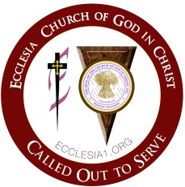

“There is no Church; like this Church; near this Church; So, this must be the church.”

The Ecclesia Family Welcomes all first time Visitors and Returning Visitors to our Sunday Morning Services.
You Are A Wonderful Asset To Our Service!

